**Nutrition Assistant Manager**

Ayan Das

dasayan348@gmail.com

### 1 INTRODUCTION

**1.1 Description**

This project is a web application that returns nutritional values of the food items that the user has uploaded as an image. This is achieved by using Flask which is a famous python library. I have also used MySQL to store credentials and APIs that provide me with nutritional information namely IBM Watson Visual Recognition and USDA database.

**1.2 Purpose**

Nutrition today is a very big concern for all individuals. With the amount of junk food consumption the world is moving to a very unhealthy place. Nutritionists serve as guides to manage our diet and make sure we do not have an unhealthy lifestyle but not everybody can afford a personal nutritionist. This is where our app comes in, it is an inexpensive way to find out how much calorie you would be consuming and therefore manage it yourself. Not only this teaches discipline but also makes you healthy.

### 2 LITERATURE SURVEY

**2.1 Existing problem**

Similar kinds of applications available on the internet are text based. They return you nutritional values based on a text input such as food input but that does not reflect how much calories your food might have.

**2.2 Proposed solution**

Same food might have different calorific values for different ways of cooking. This application is however image based so it can understand more details. If you are not consuming the full dish but only a part of it you can upload the part of food you are consuming and it will return values for only the amount you are consuming. Thus image based nutrition management systems perform better.

### 3 THEORETICAL ANALYSIS

**3.1 Block diagram Diagrammatic overview of the project.**

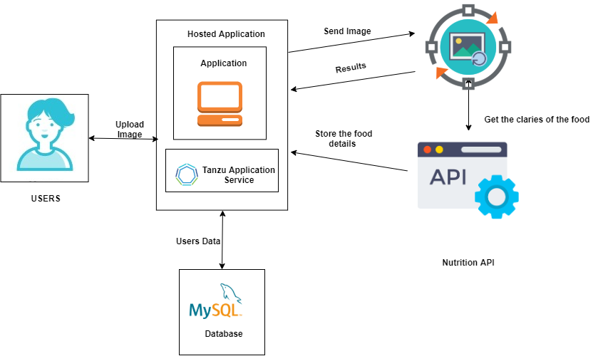

**3.2 Hardware / Software**

Hardware requirements: Working PC, internet connection

Software requirements: Python3, Remote MySQL, XAMPP, docker,

### 4 EXPERIMENTAL INVESTIGATIONS

1. Understanding how to insert and fetch data from MySQL
2. Understanding how to work with APIs - fetch response from various APIs and parse the response they returned (mostly in .json format)
3. Learning how to style using HTML and CSS
4. Learning how to build images, and use existing images from hub.docker.com

### 5 FLOWCHART



### 6 RESULT

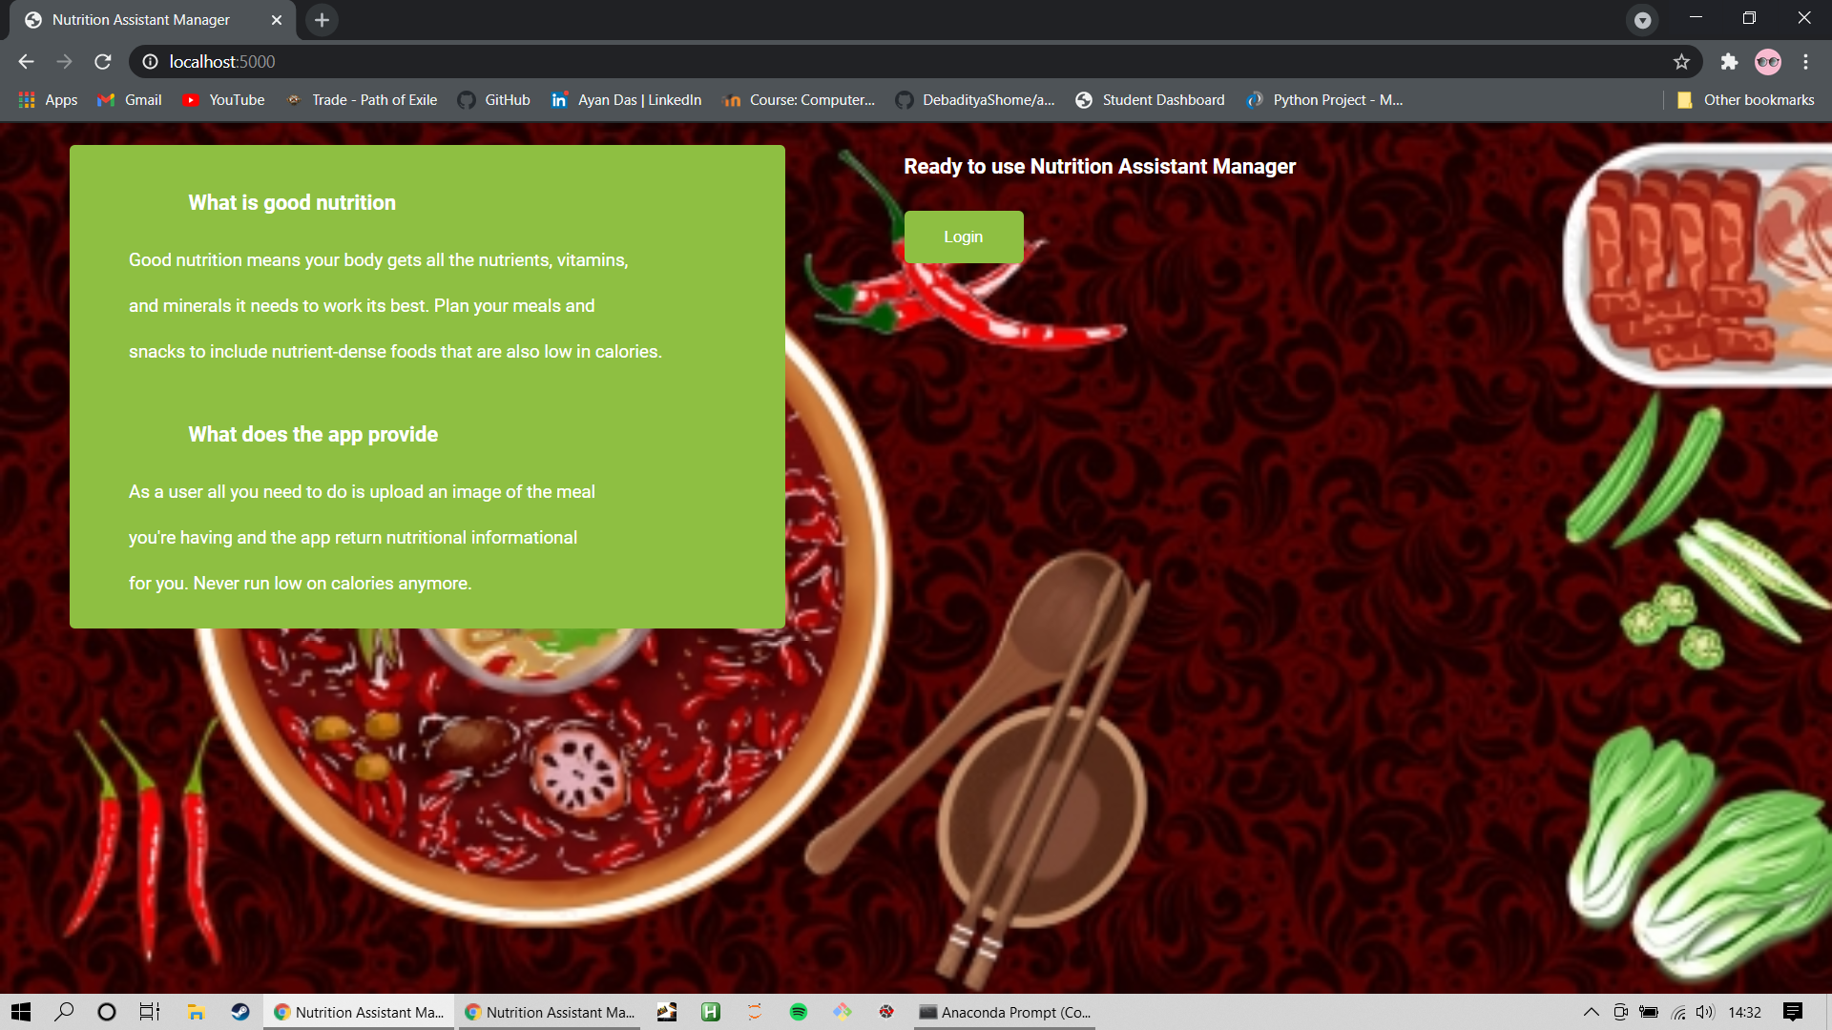

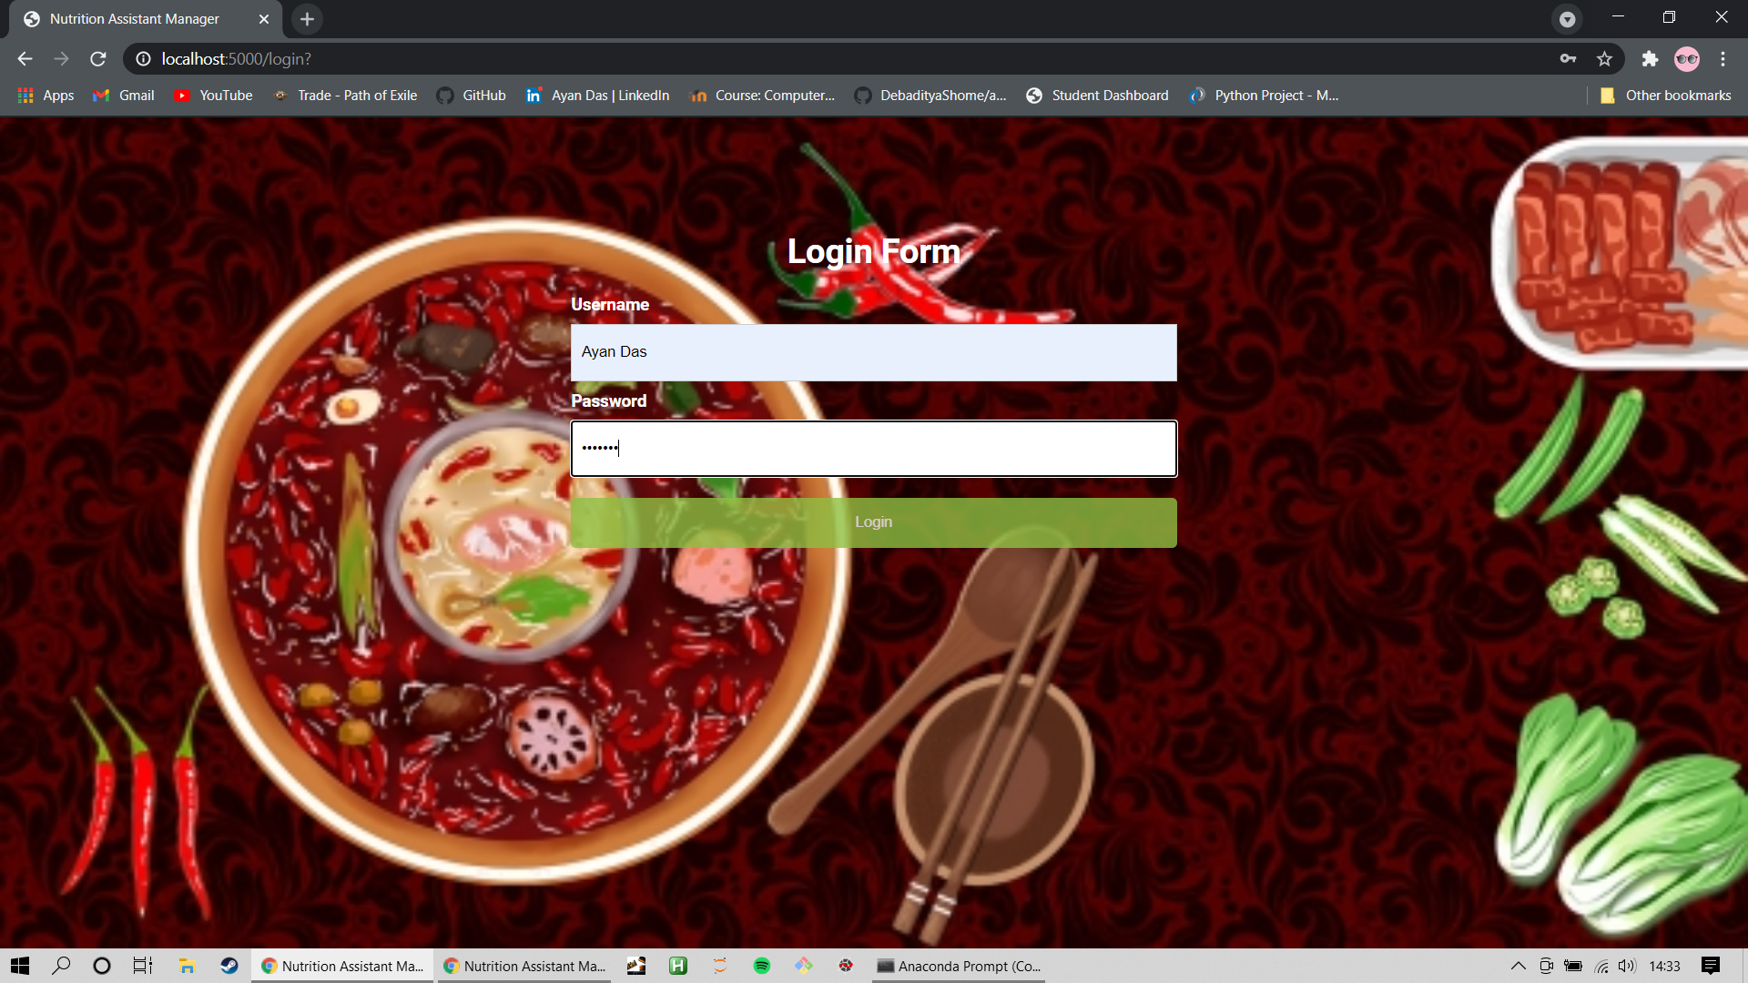

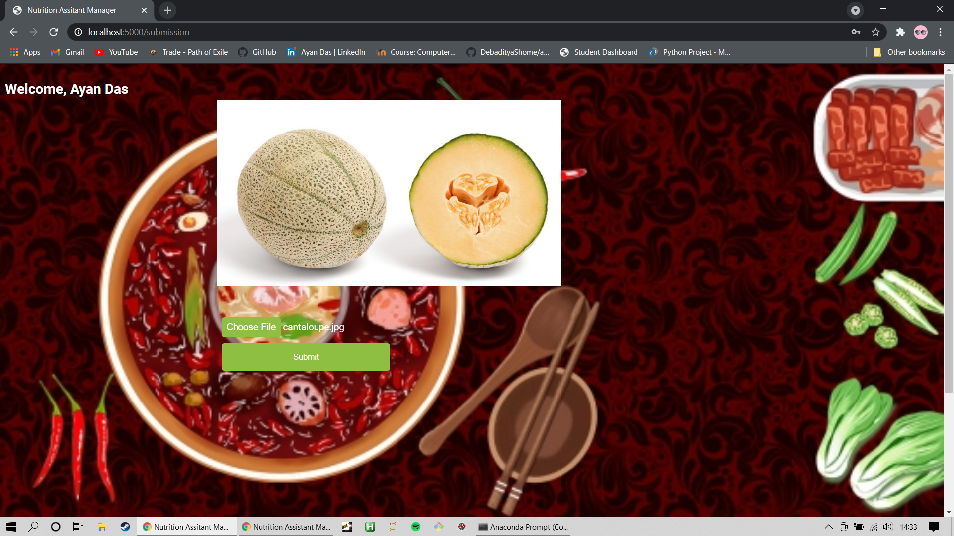

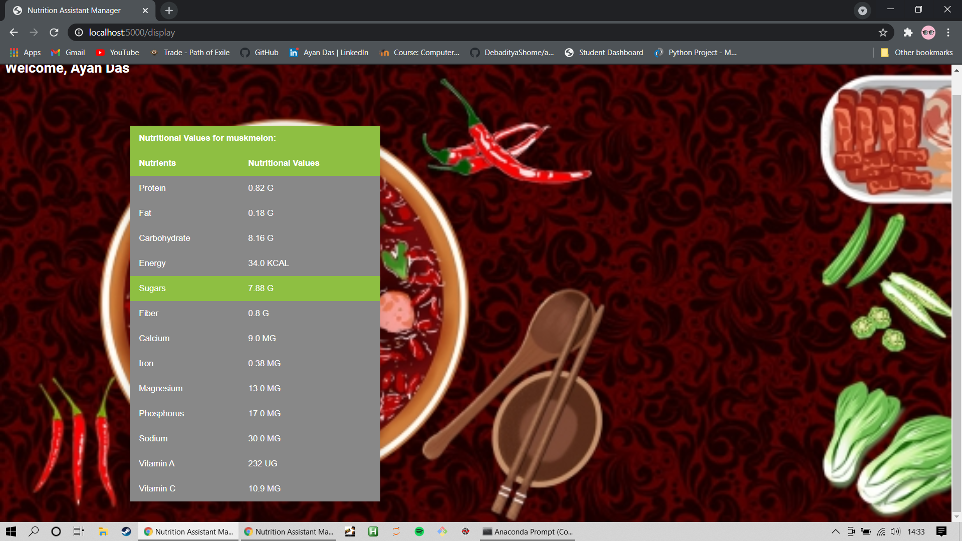

### **7 ADVANTAGES & DISADVANTAGES**

Advantages:

1. Provides better information on nutritional values by using visual recognition.
2. Can understand if a item is branded and then provide nutritional values of the specific brand
3. Can distinguish between different amount of servings

Disadvantage:

1. Can misclassify similar looking food
2. Can not determine specific ingredients from food items

### 8 APPLICATIONS

Applications for a Nutrition Assistant Manager are vast. Some of the more common ones are:

* Fitness Tracker/ Calorie Tracker
* Medical Apps for patients with high cholesterol or sugar etc.

### 9 CONCLUSION

This project has been a challenge that was fun to overcome. So many ideas incorporated into a single application makes up for a good challenge. The application is not 100% accurate as foods can look similar. The ingredients in the dishes cannot be distinguished in certain scenarios so the application is not able to predict correctly. Besides these constraints the application provides very good information.

### 10 FUTURE SCOPE

Enhancements that can be made in the future:

1. UI Improvement
2. Scaling the application to handle more requests
3. Building mobile app for mobile users.

### 11 BIBLIOGRAPHY

[1]<https://www.w3schools.com/html/> - W3schools html guide

[2]<https://www.w3schools.com/w3css/defaulT.asp> - W3schools CSS

[3]<https://smartinternz.com/Student/badge_workspace/9775> - SmartInternz dashboard

[4]<https://fdc.nal.usda.gov/api-guide.html> - USDA APi docs

[5]<https://cloud.ibm.com/apidocs/visual-recognition/visual-recognition-v3?code=python> - IBM Watson Visual Recognition API docs

### APPENDIX

**A. Source Code**

from flask import Flask, render_template, request, redirect, url_for, session

import requests, json, os

from ibm_watson import VisualRecognitionV3

from ibm_cloud_sdk_core.authenticators import IAMAuthenticator

from flask_mysqldb import MySQL

import MySQLdb.cursors

app = Flask(__name__)

app.secret_key = 'a'

app.config['MYSQL_HOST'] = "remotemysql.com"

app.config["MYSQL_PORT"] = 3306

app.config['MYSQL_USER'] = "lypD47Dxuh"

app.config['MYSQL_PASSWORD'] = "EATLsr4rTp"

app.config['MYSQL_DB'] = "lypD47Dxuh"

mysql = MySQL(app)

@app.route('/')

def index():

return render_template('index.html')

@app.route('/login', methods = ["POST", "GET"])

def login():

"""

Login page with username and password

"""

return render_template("login.html")

@app.route('/submission', methods=["POST", "GET"])

def submission():

if request.method == "POST":

name = request.form["username"]

password = request.form["password"]

session['name'] = name

session['password'] = password

cursor = mysql.connection.cursor()

cursor.execute('INSERT INTO user_details VALUES(NULL,% s, % s)',(name, password))

mysql.connection.commit()

a = session['name']

cursor.execute("SELECT * FROM `user_details` WHERE `username` = %s",[a])

account = cursor.fetchone()

return render_template("submission.html", account = account[1])

else:

return redirect(request.url)

@app.route('/display', methods = ["POST", "GET"])

def display():

"""

Display page that displays nutritional value of input image of food name

"""

if request.method == "POST":

image = request.files["food"]

authenticator = IAMAuthenticator('2A6BucKErMHbNpKGwdyGMBTsAZYxRYmm8Rxr0chzTvfm')

visual_recognition = VisualRecognitionV3(

version='2018-03-19',

authenticator=authenticator)

visual_recognition.set_service_url('https://api.us-south.visual-recognition.watson.cloud.ibm.com/instances/80c78105-880f-4bb7-b79c-93764795ee73')

classes = visual_recognition.classify(images_filename=image.filename,

images_file=image ,classifier_ids='food').get_result()

data=json.loads(json.dumps(classes,indent=4))

foodName=data["images"][0]['classifiers'][0]["classes"][0]["class"]

nutrients = {}

USDAapiKey = '9f8yGs19GGo5ExPpBj7fqjKOFlXXxkJdMyJKXwG3'

response = requests.get('https://api.nal.usda.gov/fdc/v1/foods/search?api_key={}&query={}&requireAllWords={}'.format(USDAapiKey, foodName, True))

data = json.loads(response.text)

concepts = data['foods'][0]['foodNutrients']

arr = ["Sugars","Energy", "Vitamin A","Vitamin D","Vitamin B", "Vitamin C", "Protein","Fiber","Iron","Magnesium",

"Phosphorus","Cholestrol","Carbohydrate","Total lipid (fat)", "Sodium", "Calcium",]

for x in concepts:

if x['nutrientName'].split(',')[0] in arr:

if(x['nutrientName'].split(',')[0]=="Total lipid (fat)"):

nutrients['Fat'] = str(x['value'])+" " + x['unitName']

else:

nutrients[x['nutrientName'].split(',')[0]] = str(x['value'])+" " +x['unitName']

return render_template('display.html', x = foodName, data = nutrients, account = session['name'])

else:

return redirect(request.url)

if __name__=='__main__':

app.run(debug=True)